Question 1

a) Solve for x in each of the following:

- (3)
- (2)
- (4)

b) Given the function: 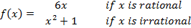

Find the value of:

(i) (2)
(ii) (2)
[13]

Question 2

The equation of a hyperbola is given by . Write down the equation of the image after each of the following transformations:

a) a vertical shift of 1 unit (1)
b) a horizontal shift of –4 units (1)
c) a vertical shift of –3 units and a horizontal shift of 4 units (2)
d) the equations of the new asymptotes are and (2)
e) shifting the graph vertically so that it passes through the point (3; 5) (3)
[9]

Question 3

- . Determine from first principles. (5)
- Differentiate with respect to x. Leave all answers with positive exponents.
- (2)
- (4)

- Find the gradient of the graph at the point where . (3)
[14]

Question 4

a) Asisipho is a student who has a part-time job. She started on a salary of R1 500 per month and has received a 1,5% increase every two months.

(i) If Asisipho has been working for one year, what is her salary now? (3)
(ii) What was Asisipho’s total earnings for the year? (5)

b) If a motor car is damaged in an accident and the cost of repairs is more than 70% of the book value of the car, then the insurance company will write off the car. Shereen’s car that she bought at the beginning of 2002 for R70 000, was damaged in an accident at the beginning of 2008. The estimated cost of repairs is R22 500.

(i) Calculate the book value of the car, if its value has decreased 22% per year, calculated on diminishing balance. (3)
(ii) Determine whether or not the insurance company will write off the car and explain why you say so. (2)
(iii) How much would Shereen have to have invested each month, from January 2002 until December 2008, at 7,5% interest per annum, calculated monthly, in order to have R80 000 to pay towards a new car? (4)
[17]

Question 5

a) Consider the sequence: 6; 10; 16; 24; 34; …

(i) If the sequence behaves consistently, determine the next two terms of the sequence. (2)
(ii) Calculate a formula for the n^{th} term of the sequence. (4)
(iii) Use your formula to calculate n if the n^{th} term in the sequence is 1264. (4)
b) A simple instrument has many strings, attached as shown in the diagram. The difference between the lengths of adjacent strings is a constant, so that the lengths of the strings are the terms of an arithmetic series.
The shortest string is 30 cm long and the longest string is 50 cm. The sum of the lengths of all the strings is 1240 cm.

(i) Find the number of strings. (3)
(ii) Find the constant difference in length between adjacent strings. (3)
[16]

Question 6

Sketched below are graphs of and .

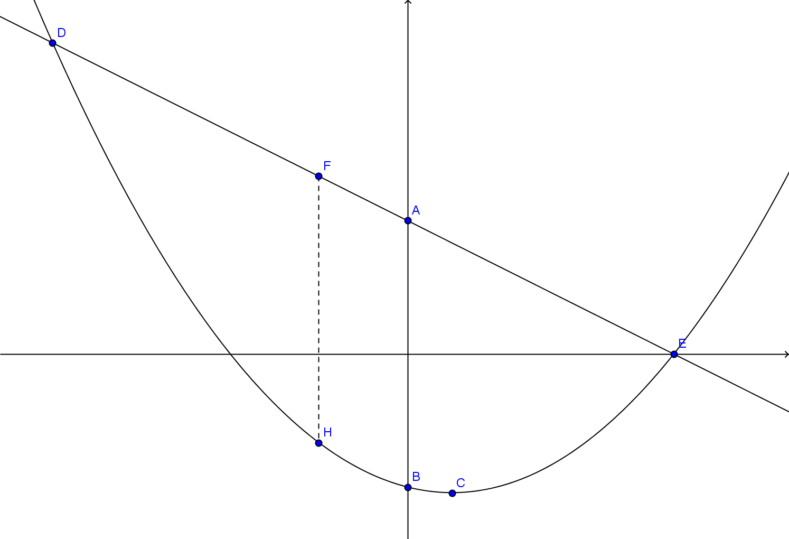

a) Calculate the distance AB. (2)

b) Determine the co-ordinates of C, the turning point on the parabola. (4)

c) Calculate the co-ordinates of D and E, the points of intersection of the two graphs.(6)

d) Calculate the maximum length of FH between D and E where F lies on the straight line, H lies on the parabola and FH is parallel to the y-axis. (7)
[19]

Question 7
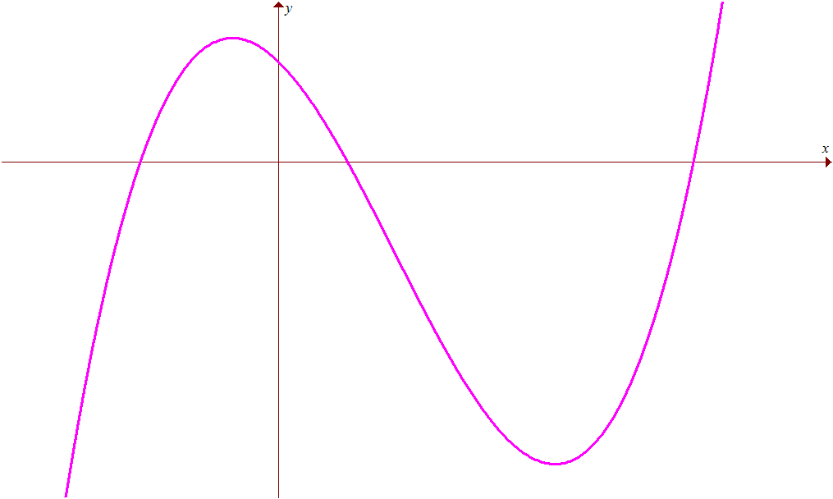
The figure represents the graph of . F is a local minimum point.
D
E
A
B
C
F

a) Show that and . (6)

b) A is the point . Calculate the co-ordinates of B and C, the x-intercepts of the graph. (5)

c) Determine the co-ordinates of D, the local maximum point. (5)

d) If E is the y-intercept, prove algebraically that B lies on the straight line EF. (4)
[20]

Question 8

The MOD computer company manufactures modems for use with computers. Model A is used internally and model B externally. The company can manufacture x model A’s and y model B’s each month, but no more than a total of 240. There is a need for at least 20 model A’s and 45 model B’s each month.

a) Represent the above information as a set of inequalities. (4)

b) Model A requires 40 hours to make while model B requires 20 hours. However, a maximum of 6 000 hours is available each month. Express these constraints as an inequality. (2)

c) Graphs the set of inequalities in (a) and (b) and clearly indicate the feasible region.(5)

d) The company makes a profit of R240 on model A and R180 on model B.
(i) Write down an expression for the monthly profit. (1)
(ii) Determine how many of each type of model should be produced to make a maximum profit. (2)
(iii) Determine this maximum profit. (1)
[15]

Question 9

A radioactive element, like Strontium-90 loses some of its radioactivity over time. This is called radioactive decay. A formula for radioactive decay is: N = N₀(2,718)^{–kt} where N₀ is the amount of a radioactive substance at time 0, N is the amount at time t, and k is a positive constant. The half-life of Strontium-90 is 25 years. This meanst that when t = 25, N = ½N₀.

a) Find k (correct to four decimal digits) in the above formula. (4)

b) Find how much of a 36 gram sample will remain after 100 years. (2)
[6]

Question 10

An uncovered tank is constructed on a square base and contains of a liquid.

a) If the length of one side of the base is x m, show that the area of the surface contact between the tank and the liquid is . (5)

b) What are the dimensions of the base if the surface contact between the tank and the liquid is to be a minimum? (5)
[10]

Question 11

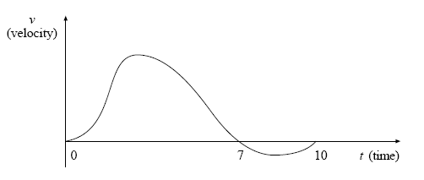
a)

A particle is observed as it moves in a straight line in the period between t = 0 and
t = 10. Its velocity (v) at time (t) is shown on the graph above.

You have been provided with a copy of this graph on the answer sheet. Answer the following questions on this answer sheet.

(i) On the time axis, mark and clearly label with the letter Z the times when the acceleration of the particle is zero. (2)
(ii) There are three occasions when the particle is at rest, i.e. at t = 0, t = 7 and
t = 10.
The particle is furthest from its initial position on one of these occasions. Indicate which occasion, giving reasons for your answer. (3)

b) A layer of plastic cuts out 15% of the light and lets through the remaining 85%.

(i) Show that, when two layers of the plastic are placed on top of each other they let through 72,25% of the light. (2)
(ii) How many layers of the plastic are required to cut out at least 90% of the
light? (4)
[11]

