Memorandum Paper 1

Question 1

a) (i)
(3)

(ii) (2)
–3
4
+ – +
(iii)
(4)

b) (i) (2)
(ii) (2)
[13]

Question 2

a) (1) b) (1)

c) (2) d) (2)

e)
(3)
[9]

Question 3

a) 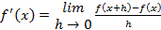
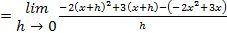
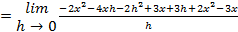
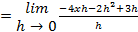
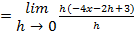
(5)
b) (i)
(2)

(ii) (4)

c)
Therefore the gradient where will be (3)
[14]
Question 4

a) (i) A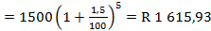 (3)

(ii) S 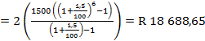 (5)

b) (i) Book value (3)

(ii) 70% of the book value =
Since this value is greater than the estimated cost of repairs the insurance
company will write off the car. (2)

(iii) 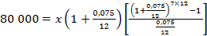
per month (4)
[17]

Question 5

a) Consider the sequence: 6; 10; 16; 24; 34; …

(i) 46; 60 (2)

(ii)
(4)

(iii)
(4)

b) (i)
§
§ So, there are 31 strings (3)

(ii) §
§
§ (3)
[16]

Question 6

a) AB = § (2)

b) § § C § (4)

c) §
§
§
§
§ D § and E § (6)

d) §
§

§ §
§ §
§ FH = § units (7)

Note: It is a maximum since the gradient is + and then – before and after §
[19]

Question 7
a) § §
§ §
§ §

§ and §
(6)
b) §
y § §
§
§

B § and C § (5)

c) §
§
§
§ § D §
. (5)
d) E §, F §, B §

Gradient of EF = § Gradient of EB = §

These points are co-linear (they lie on the same straight line) (4)
[20]

Question 8

a) § … ( § …( § … ( (4)

b) § … ( (2)

c)

(5)

d) (i) P = § (1)

(ii) B § (2)

(iii) P = § (1)
[15]

Question 9

a) §
§ (4)

b) N § grams will remain

OR: §grams (2)
[6]

Question 10

a) § §

Surface contact = § (5)

b) Surface contact = § §
§
§
§

Therefore the base’s dimensions will be 7 m x 7 m.

Note: It is a minimum since the gradient is – and then + before and after § (5)
[10]

Question 11

a) (i)

Z
(2)
Z

(ii) The particle has a positive velocity from t = 0 until t = 7. Then it stops and reverses (negative velocity) until t = 10. This means than that it was the furthest from its initial position at t = 7. (3)

b) (i) 1st layer = 85%; 2nd layer = 85% ( 0,85 = 72,5%. (2)

(ii) That means to let through 10% of the light …

§
§
§.

Therefore you will need at least 15 layers of plastic. (4)
[11]

