Total: 150 marks

Reading Time: 10 minutes Writing Time: 3 hours
This paper contains 9 pages (including this cover), a data sheet and an answer page. Check that your paper is complete.
Please read the following instructions carefully:

1. Answer all questions on foolscap paper. Answer Questions 3 & 4 on the answer
sheet provided (where applicable).
2. Pay careful attention to time management and mark allocation.
3. Write legibly and not in pencil.
4. Calculators may be used unless otherwise instructed.

5. All necessary calculations must be clearly shown. You will NOT receive
full credit if you write down only the answers and show no working out.
NAME:
Q1  [14] | Q2  [9] | Q3  [4] | Q4  [9] | Q5  [9] | Q6  [14] | Q7  [16] | Q8  [5] | Q9  [12] | Q10  [18] | Q11  [6] | Q12  [10] | Q13  [9] | Q14  [10] | Q15  [5]
TOTAL: $\frac{}{\text{150}}$

QUESTION 1
Solve for x correct to 2 decimal digits where necessary
a) (x – 4)(x – 3) = 6 (3)
b) x ² – 10x – 24 < 0 (3)
c) log₂x – log₂(x+2) = 1 (4)
d) 2 ^{x} . 3 ^{x+2} = 120 (4)
[14]
QUESTION 2
a) Consider the series
−2 + 5 − 2 + 9 − 2 + 13 − 2 + 17 − ….
Find the sum of the first 200 terms of the sequence. (5)
b) Consider the sequence
6 ; 18 ; 54 ; 162 ; ….
How many terms of the sequence add up to 177 144? (4)
[9]
QUESTION 3
The graph of y = f(x) is sketched below.
•
1
•
− 1
0
2
1

On the set of axes drawn on the ANSWER SHEET, draw the graphs of
(a) y = f(− x) (2)
(b) y = f(x − 3) (2)
[4]
QUESTION 4 ANSWER THIS QUESTION ON THE ANSWER SHEET
Look at the pattern of the tiles shown and then fill in the table below. Show all calculations, and fill in the table.

Fig(i) Fig(ii) Fig(iii)

[9]
 | fig(i) | fig(ii) | fig(iii) | fig(iv) | fig(n)
Number of grey tiles | 3 | 5
Number of white tiles | 2 | 6
Number of black tiles | 1 | 4

QUESTION 5
5(3)⁴ +5(3)³ +5(3)² + ….
a) Explain why the series converges. (2)
b) Find S∞ (2)
c) Find S₉ correct to two decimal digits. (3)
d) Hence determine
$\sum_{n=\text{10}}^{∞}{5(3)^{5−n}}$ correct to two decimal digits. (3)
[10]

QUESTION 6
A promotions company manufactured x flags and y beanies for the World Cup. They had to produce at least 6 000 promotional items per day, but the factory could not cope with a production of more than 12 000 items per day. The number of beanies produced could not be greater than twice the number of flags manufactured each day.
The selling price of a flag was R25 and that of a beanie was R50.
- Write down all the constraints involving x and y. (4)
- Use the graph paper provided to sketch the feasible region. (4)
- Use your graph to determine the number of flags and beanies
that should have been produced to ensure maximum income.
Show clear working. (4)
- After the World Cup the profit on each item was reduced to
1/10 of the original price. Does this affect the point on the
feasible region which maximizes income? Explain your answer. (2) [14]
QUESTION 7
- Mrs Ivana Loan borrows R510 000 to buy a house. She pays back the loan over 20 years (starting one month after receiving the loan). The interest rate is 14% p.a. compounded monthly.
- Calculate her monthly repayments. (4)
ii) How many months would it take her to repay the loan if she increases her monthly repayment to R10 000? (4)
iii) How much did she save by increasing her installments? (2)
- A company plans to replace machinery in ten years time. The new machinery will cost R180 000.
i) What amount should be saved each month if the bank pays 12% p.a
compounded monthly?
(The first deposit is made at the end of the first month of the first year). (4)

ii) What is the effective interest rate? (3)
[15]

QUESTION 8

David plays with two juice boxes of the type shown on the left. He arranges them in two ways:
18

p
q
Figure (a)
Figure (b)
18
q
18
p
q
q
p
p
q

In figure (a) the sum of the dimensions is 31. In figure (b) it is 35.
Find p and q. [6]

QUESTION 9
- Determine D_{x}$\left[\frac{5x^{2}−3x}{\sqrt{x}}\right]$ (4)
- Find $\frac{\text{dy}}{\text{dx}}$ if x³y = $\frac{1}{6}$ (3)
- If f(x) = 2x² , find $f^{'}(x)$from first principles. (5)
[12]
QUESTION 10

O
D
B
C

g
A
E

f

The graph of f(x) = – x³ + ax ² + bx + c has x-intercepts at B(2;0) and C(–3; 0) and cuts the y-axis at E. A and B are turning points.
N.B. The graph is not drawn to scale.

- Determine
- the values of a, b and c. (5)
- the x-co-ordinate of A, the local minimum if
f(x) = –x³ + x² + 8x – 12 (3)
- the equation of the tangent g at E. (2)
- the co-ordinates of the point, D, where the tangent g cuts the
graph of f again. (4)
- Use the graph to find x if f(x).$f^{'}(x)≤0$. (2)
- Find the equation of h, the reflection of f about the y-axis. (2)
[18]

QUESTION 11
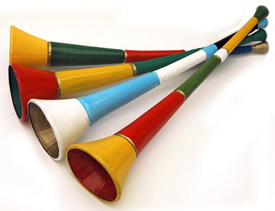
The noise made by a vuvuzela trumpeting is measured in decibels by the
formula V = 2t³ +$\frac{\text{10}}{t}$ where t is time measured in seconds

and 0 < t ≤ 4 . Find the maximum noise that can be emitted in decibels
(correct to the nearest decibel). [7]

QUESTION 12
f(x) = $\frac{3}{x−2}+1$
- Write down the equation of the asymptotes of f. (2)
- Sketch the graph of f clearly showing the intercepts on the axes
as well as the asymptotes. (4)
- Write down the equation of the graph obtained if f is shifted 4 units to
the left and 2 units down. (2)
- Use your graph to find the values of x for which
$\frac{3}{x−2}+1 ≥ −\frac{1}{2}$ (2)
[10]

QUESTION 13

In the 2010 FIFA logo there is a curve that approximates the exponential curve.

A(2; 4)
.

f(x) = a^{x} ; x Є [ –2; 3 ]. A(2; 4) is a point on f.
a) Find the value of a. (1)
b) Find the equation of g if g is a reflection of f about y=x.
Write your answer in the form : g(x) = …….. ; x Є [….] (3)
c) g is reflected about the x-axis to obtain h,
i) Write down the equation of h in the form h(x) = ..... (2) ii) Find the value of h(1) (1)
iii) Find the value of x if h(x) = 2 (2)
[9]

QUESTION 14

Below is a picture of The Moses Mabhida Stadium in Durban while under construction.

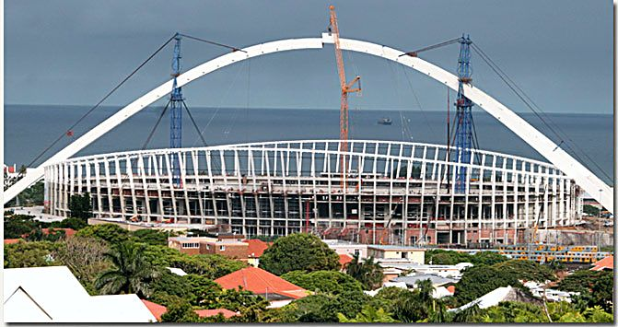

The arch above the stadium is approximated by the parabola below.
The equation of the parabola is y = $\frac{−\text{106}}{ (\text{175})^{2}}(x−\text{175})^{2}+\text{106}$

Y
O
B

D
C

A
N
X
E

- How high above the ground is the highest point, B, of the parabola? (1)
- What is the distance (on the ground) between the two endpoints
of the arch? (2)
- If CN is a crane positioned 55m to the left of AB, how tall is
the crane (correct to the nearest m)? (3)
- Find the average gradient between B and C. (2)
- Find the area of ∆DBC. (2)
[10]
QUESTION 15

a) If f(1) = 5 and f(x+1) = 2f(x), determine the value of f(5)
showing all working. (3)
b) Hence (or otherwise) find the value of f(100) leaving your answer
in exponential form. (3) [6]

QUESTION 6


